ANSWER KEY

YEAR 2019  
  
LEVEL : PRIMARY 6  
  
SCHOOL : CATHOLIC HIGH SCHOOL  
SUBJECT > ENGLISH LANGUAGE  
  
TYPE : MID-YEAR EXAMINATION (2019)

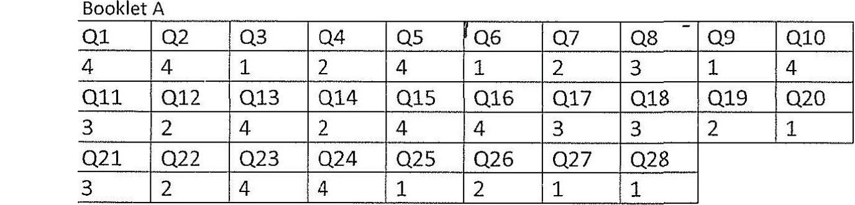

Q29.Q  
  
Q30.K  
  
ABL C  
  
Q32.D  
  
Q33.H  
  
Q34.A  
  
O35.  
  
Q36.G6  
  
Q37.L  
  
Q38.M  
  
Q39. immediately  
Q40. it  
  
Q4l. imagination  
QA42. solitary  
Q43. appearance  
Q44. stifled  
  
Q45. panicking  
O46. forgotten  
O47. murmured  
O48. silence  
Q49. demeanour  
Q50. grabbing  
Q51. become  
Q52. rate  
  
Q53. like  
  
O54. for